**13.Session Tracking Techniques:**

* **Session** simply means a particular interval of time.
* **Session Tracking** is a way to maintain state (data) of an user. It is also known as **session management** in servlet.
* Http protocol is a stateless so we need to maintain state using session tracking techniques.
* Each time user requests to the server, server treats the request as the new request. So we need to maintain the state of an user to recognize to particular user.
* HTTP is stateless that means each request is considered as the new request.

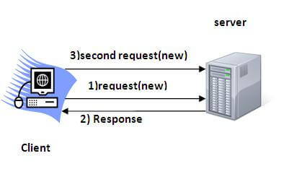

### Session Tracking Techniques:

* **Cookies**
* **Hidden Form Field**
* **URL Rewriting**
* **HttpSession**